Food Science Frontier Research Forum

International University Consortium of Food Science and Nutrition

(First Announcement)

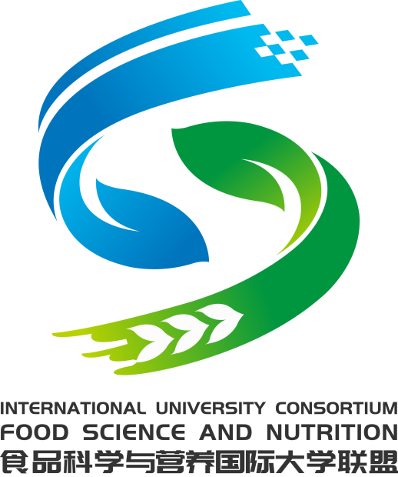

Zhejiang Gongshang University, Hangzhou, China
2nd-3rd November 2023

The sciences behind the food and human wellness have become main concerns of food science research in the past many years across the world and attract growing interests from researchers of food science as well as other scientific disciplines. How future food meet the challenges of sustainability and consumers’ demands of health and wellbeing requires integrated actions and collaborations by scientists from different regions and different scientific fields. To this background, the International University Consortium of Food Science and Nutrition (IUCoFSN), composed of the University of Leeds (UK), Massey University (New Zealand), Wageningen University (The Netherlands), Kyoto University (Japan), Guelph University (Canada), Massachusetts University (USA), and Zhejiang Gongshang University (China), has been exploring possibilities of global efforts for global solutions. Since its establishment in 2016, the consortium has successfully organized six international conferences to help to share research progresses and to promote international collaborations.
The IUCoFSN is now pleased to announce its 7th international conference with the theme of "Food Science and Nutrition Frontier Forum" to be held in Hangzhou, 2nd – 3rd November 2023. The conference will invite world-leading food scientists to report latest research findings and to share views and vision of future food. The conference will be onsite and offline with invited talks, poster presentations and face-to-face discussion. Themes of the conference include: Food colloids and soft matter, Food oral processing and sensory perception, Food nutrition and digestion, Gut microbiota and health, Artificial intelligence and emerging technologies for food science and nutrition. Colleagues and graduate students of food science and other related disciplines as well as industrial researchers are very welcome to attend.

Aims and objectives of the 2023 Forum:
- To showcase the latest research developments and ideas in frontier areas of food science and nutrition
- To promote closer links and international research collaborations
- To inspire thinking of new research ideas and applications

Themes and topics:
- Food soft matters, structure, material properties and functionalities;
- Food oral processing, sensory perception and preference;
- Food digestion and human nutrition;
- Food microbes and human health;
- Artificial intelligence and emerging technologies for food science and nutrition.

Date of the forum: 2nd-3rd November 2023
Location of the forum: Hangzhou, China
Hangzhou is served by an international airport and can be reached directly from Europe via KLM, from Japan via ANA, from America via UA, from Canada via ACE, etc. Alternatively, Hangzhou is only one hour by train from Shanghai Hongqiaou Rail Station.

Organisers:
The International University Consortium of Food Science and Nutrition Massey
Zhejiang Gongshang University (China)
Co-organiser:
Zhejiang Instutue of Food Science and Technology
Contacts:
Ms. Peili Xu and Ms. Dongmin
School of Food Science and biotechnology
Zhejiang Gongshang University
Xiasha, Hangzhou
Zhejiang Province 310018
P. R. China
Tele: 00(86) 571 28008906
Fax: 00(86) 571 28008900
Email: dm901130@zjgsu.edu.cn

